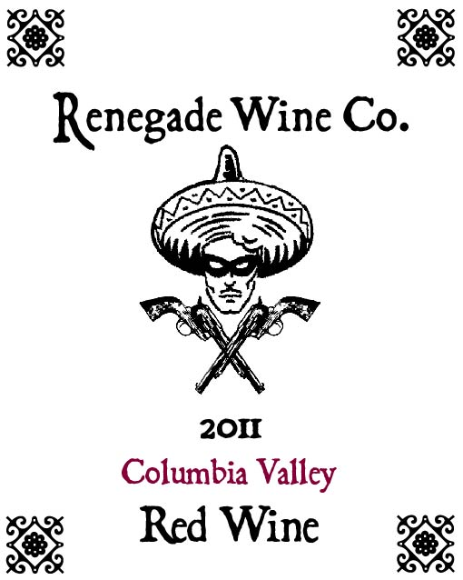

The Renegade Wine Co. is very excited to release the 2011 Renegade Wine Co. Red Wine. And you’ll be glad to know that we made enough this year to last more than 5 months! We could have called this wine a Cabernet, since it is 95% Cabernet Sauvignon, 4% Malbec, and 1% Petit Verdot. It certainly drinks like a Washington State Cabernet, with lots of red and black fruits, scents of loamy minerality, and fine grained tannins that are matched with balanced acidity which tells us you could actually lay this down for a while. Like all the Renegade wines, this drinks as well as something twice as expensive. Certainly a candidate to buy by the case! Don’t hesitate, be a Renegade!

